2025 - 2026
THE Andersons
Team: LST-C
Design report
Aarya Ray Chaudhuri,
Denys Herasymchuk,
Ellen van Eygen,
Faizan Ali,
Jeff Tielen,
Ryan Omondi,
Stjepan Raguž

Table of Contents
1. Introduction 5
2. Requirements analysis 6
2.1. Functional requirements 6
2.1.1. Use Case Diagram 6
2.1.2. Use Cases 7
2.2. Non-functional requirements 22
3. Data Model 23
4. Priority by functionality 24
5. Backlog with User Stories 25

Introduction

Requirements analysis
Introductory information for this section of the report.

Your text

Functional requirements

Use Case Diagram
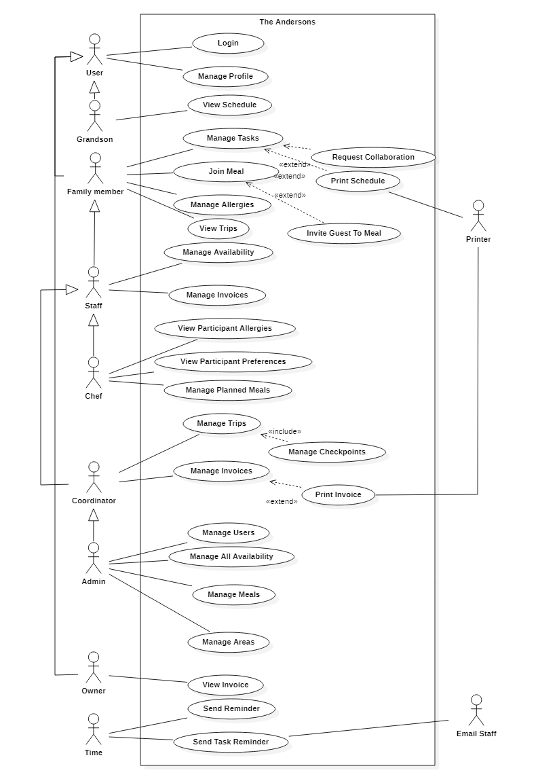

Use Cases

Log In
Functionality: As a user, I can log in to the system.

Preconditions: The actor has an existing account.

Data model view:
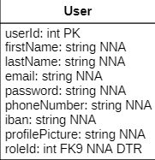

Figma link:
https://www.figma.com/proto/vIM2q4OzEAyHcM53SsJ0un/Workspace?node-id=9-1254&t=5GRu6aFU9ikrMxmD-1&scaling=min-zoom&content-scaling=fixed&page-id=0%3A1&starting-point-node-id=14%3A19&show-proto-sidebar=1

Manage Profile
Functionality: As a user, I can manage my profile.

Preconditions: The actor is logged in.

Normal flow: The actor presses the “Edit Profile” button. The actor is presented with profile management options. The user enters the changes and saves them. The system validates changes and updates profile.

Data model view:
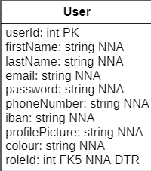
Figma link:
https://www.figma.com/proto/vIM2q4OzEAyHcM53SsJ0un/Workspace?node-id=14-19&t=yQDskG1GiYPcP8R3-1&scaling=min-zoom&content-scaling=fixed&page-id=0%3A1&starting-point-node-id=14%3A19&show-proto-sidebar=1

View Schedule
Functionality: As a grandson, I can view the schedule.

Preconditions: The actor is logged in.

Data model view:
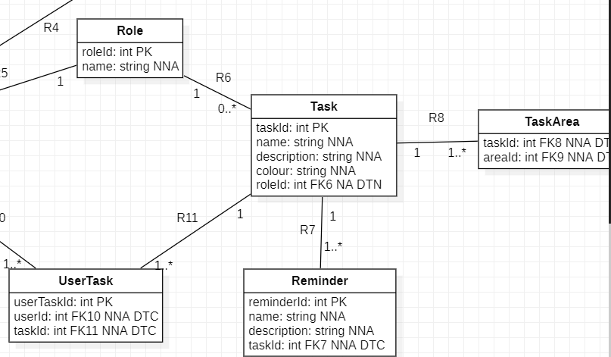
Figma link:
https://www.figma.com/proto/vIM2q4OzEAyHcM53SsJ0un/Workspace?node-id=32-595&t=26MZ9PLFm8tPmOQZ-1&scaling=scale-down-width&content-scaling=fixed&page-id=4%3A2&starting-point-node-id=32%3A595

Manage Tasks
Functionality: As a family member, I can manage tasks.

Preconditions: The actor is logged in.

Data model view:

Figma link:
https://www.figma.com/proto/vIM2q4OzEAyHcM53SsJ0un/Workspace?node-id=57-7684&t=N4wWHPb1K5PYwyFw-1&scaling=min-zoom&content-scaling=fixed&page-id=4%3A3

Request Collaboration
Functionality: As a family member, I can request a collaboration.

Preconditions: The actor is logged in.

Data model view:
Figma link:
https://www.figma.com/proto/vIM2q4OzEAyHcM53SsJ0un/Workspace?node-id=57-5997&t=PiGeA3kxwnaEogYB-1&scaling=min-zoom&content-scaling=fixed&page-id=4%3A3

Print Schedule
Functionality: As a family member, I can print a schedule.

Preconditions: The actor is logged in.

Data model view:
Figma link:
https://www.figma.com/proto/vIM2q4OzEAyHcM53SsJ0un/Workspace?node-id=57-7684&t=xVUG3HvMvPVr3z1m-1&scaling=min-zoom&content-scaling=fixed&page-id=4%3A3

Join Meal
Functionality: As a family member, I can join a meal.

Preconditions: The actor is logged in.

Data model view:
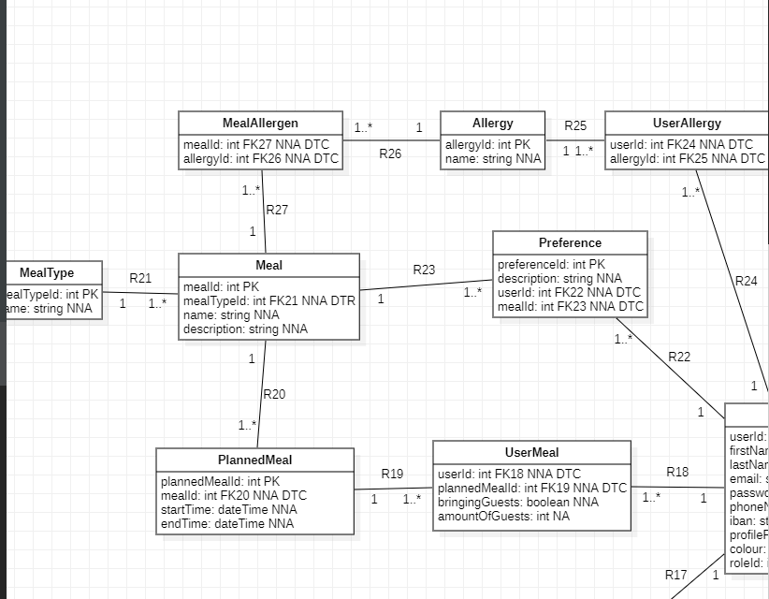
Figma link:
https://www.figma.com/proto/vIM2q4OzEAyHcM53SsJ0un/Workspace?node-id=57-9358&t=TB2UNStb4pHGYSg7-1&scaling=min-zoom&content-scaling=fixed&page-id=4%3A3

Invite Guest to Meal
Functionality: As a family member, I can invite a guest to a meal.

Preconditions: The actor is logged in.

Data model view:
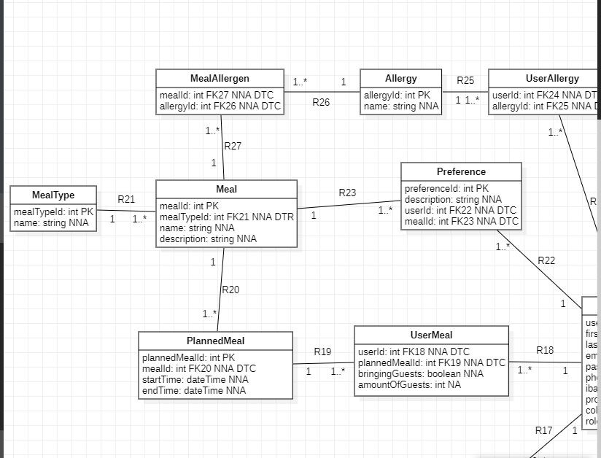
Figma link:

Manage Allergies
Functionality: As a family member, I can manage allergies.

Preconditions: The actor is logged in.

Data model view:
Figma link:

View Trips
Functionality: As a family member, I can view trips.

Preconditions: The actor is logged in.

Data model view:
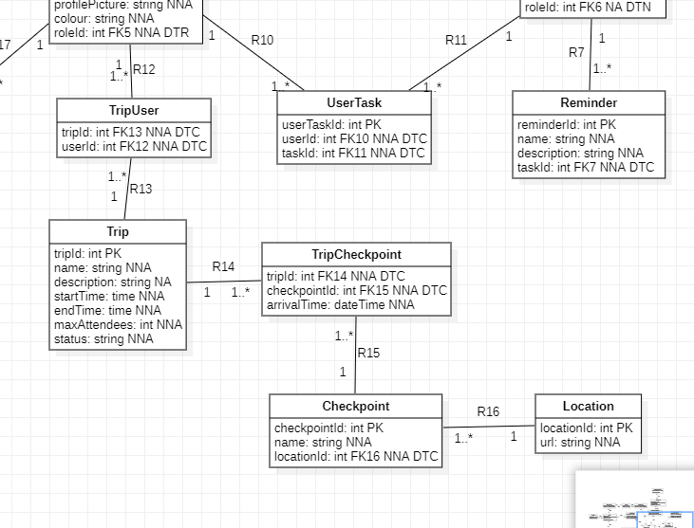
Figma link:
https://www.figma.com/proto/vIM2q4OzEAyHcM53SsJ0un/Workspace?node-id=156-1711&t=PGfKvD3Cgeky5NjU-1&scaling=min-zoom&content-scaling=fixed&page-id=4%3A3

Manage Availability
Functionality: As staff, I can manage my availability.

Preconditions: The actor is logged in.

Data model view:
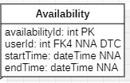
Figma link:
https://www.figma.com/proto/vIM2q4OzEAyHcM53SsJ0un/Workspace?node-id=1-146&t=6C8P5efH33vSrvhS-1&scaling=min-zoom&content-scaling=fixed&page-id=1%3A2

Manage Invoices
Functionality: As staff, I can manage invoices.

Preconditions: The actor is logged in.

Data model view:
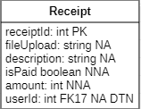
Figma link:
https://www.figma.com/proto/vIM2q4OzEAyHcM53SsJ0un/Workspace?node-id=65-3645&t=WnjJhb8qtVFV5Pxh-1&scaling=scale-down&content-scaling=fixed&page-id=1%3A2

View Participant Allergies
Functionality: As a chef, I can view participants’ allergies.

Preconditions: The actor is logged in.

Data model view:
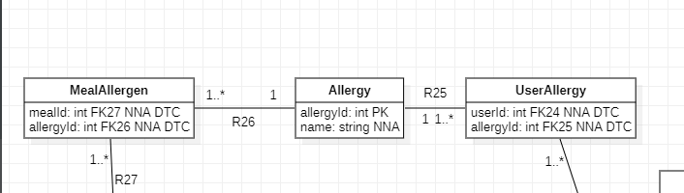
Figma link:

View Participant Preferences
Functionality: As a chef, I can view participants’ preferences.

Preconditions: The actor is logged in.

Data model view:
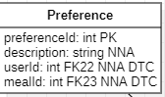
Figma link:

Manage Planned Meals
Functionality: As a chef, I can manage the planned meals.

Preconditions: The actor is logged in.

Data model view:
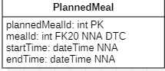
Figma link:
https://www.figma.com/proto/vIM2q4OzEAyHcM53SsJ0un/Workspace?node-id=130-3121&t=2iTjECNYHOdDlsJG-1&scaling=min-zoom&content-scaling=fixed&page-id=4%3A4

Manage Trips
Functionality: As a coordinator, I can manage trips.

Preconditions: The actor is logged in.

Data model view:
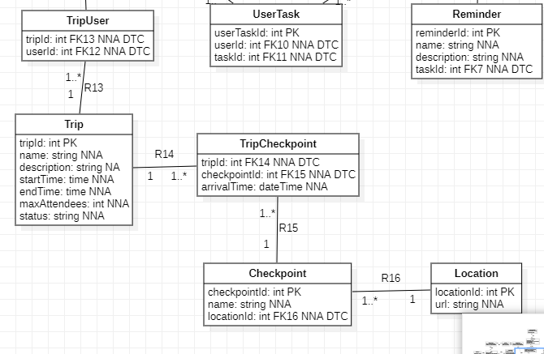
Figma link:
https://www.figma.com/proto/vIM2q4OzEAyHcM53SsJ0un/Workspace?node-id=69-165&t=HfGlacFPqGQGr4Tu-1&scaling=contain&content-scaling=fixed&page-id=1%3A3&starting-point-node-id=69%3A165&show-proto-sidebar=1

Manage Checkpoints
Functionality: As a coordinator, I can manage checkpoints.

Preconditions: The actor is logged in.

Data model view:
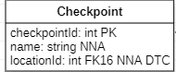
Figma link:

Manage Invoices
Functionality: As a coordinator, I can manage invoices.

Preconditions: The actor is logged in.

Data model view:
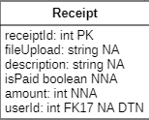
Figma link:
https://www.figma.com/proto/vIM2q4OzEAyHcM53SsJ0un/Workspace?node-id=113-7249&t=qKw5G0CKD2u78jky-1&scaling=contain&content-scaling=fixed&page-id=1%3A3&starting-point-node-id=69%3A165&show-proto-sidebar=1

Print Invoice
Functionality: As a coordinator, I can print an invoice.

Preconditions: The actor is logged in.

Data model view:
Figma link:
https://www.figma.com/proto/vIM2q4OzEAyHcM53SsJ0un/Workspace?node-id=113-7249&t=qKw5G0CKD2u78jky-1&scaling=contain&content-scaling=fixed&page-id=1%3A3&starting-point-node-id=69%3A165&show-proto-sidebar=1

Manage Users
Functionality: As an admin, I can manage users.

Preconditions: The actor is logged in.

Data model view:
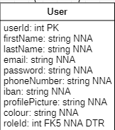
Figma link:
https://www.figma.com/proto/vIM2q4OzEAyHcM53SsJ0un/Workspace?node-id=9-2143&t=hISjaVXn5kMUavaX-1&scaling=min-zoom&content-scaling=fixed&page-id=4%3A5&starting-point-node-id=9%3A2143&show-proto-sidebar=1

Manage All Availability
Functionality: As an admin, I can all availability.

Preconditions: The actor is logged in.

Data model view:
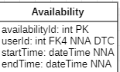
Figma link:
https://www.figma.com/proto/vIM2q4OzEAyHcM53SsJ0un/Workspace?node-id=113-22529&t=UuqHL0IGORLNXuy4-1&scaling=min-zoom&content-scaling=fixed&page-id=4%3A5&starting-point-node-id=113%3A22529&show-proto-sidebar=1

Manage Meals
Functionality: As an admin, I can manage meals.

Preconditions: The actor is logged in.

Data model view:
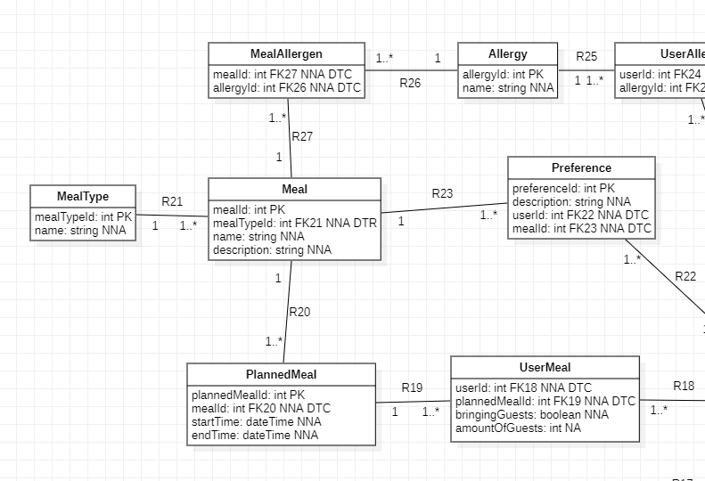
Figma link:
https://www.figma.com/proto/vIM2q4OzEAyHcM53SsJ0un/Workspace?node-id=88-482&t=cvHE3tZkvC5LsvxN-1&scaling=min-zoom&content-scaling=fixed&page-id=4%3A5&starting-point-node-id=9%3A2143&show-proto-sidebar=1

Manage Areas
Functionality: As an admin, I can manage areas.

Preconditions: The actor is logged in.

Data model view:
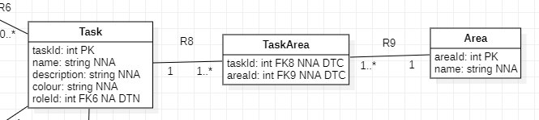
Figma link:
https://www.figma.com/proto/vIM2q4OzEAyHcM53SsJ0un/Workspace?node-id=127-6605&t=sRUQ2kTBqibvWJZw-1&scaling=min-zoom&content-scaling=fixed&page-id=4%3A5&starting-point-node-id=9%3A2143&show-proto-sidebar=1

View Invoice
Functionality: As an owner, I can view an invoice.

Preconditions: The actor is logged in.

Data model view:
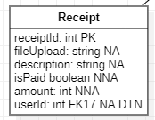
Figma link:
https://www.figma.com/proto/vIM2q4OzEAyHcM53SsJ0un/Workspace?node-id=66-223&t=VmrgDAkL63sYOOax-1&scaling=min-zoom&content-scaling=fixed&page-id=1%3A4

Send Reminder
Functionality: As time, I can send a reminder.

Preconditions: The actor is logged in.

Data model view:
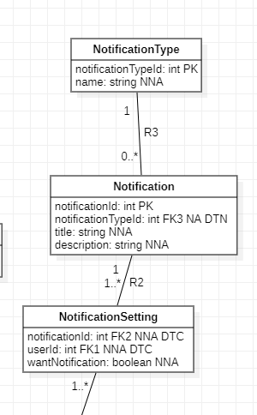
Figma link:
https://www.figma.com/proto/vIM2q4OzEAyHcM53SsJ0un/Workspace?node-id=87-7930&t=sAG3boPTF66ytLmv-1&scaling=contain&content-scaling=fixed&page-id=1%3A5

Send Task Reminder
Functionality: As time, I can send a task reminder.

Preconditions: The actor is logged in.

Data model view:
Figma link:
https://www.figma.com/proto/vIM2q4OzEAyHcM53SsJ0un/Workspace?node-id=87-7930&t=sAG3boPTF66ytLmv-1&scaling=contain&content-scaling=fixed&page-id=1%3A5

Non-functional requirements
The system must be very secure and protect all user data by enforcing authentication and authorization based on user roles. Passwords must always be encrypted when stored. Only users that are authenticated can access the system, and certain sensitive operations are only restricted to authorized roles.

The system must be reliable and ensure that the same theme and colors are consistent through every page, no matter what dedicated page users visit; whether it’s meals, schedules, tasks, trips, invoices, notifications. On top of that, it is even more important to ensure data consistency in the very same way. All the changes that users make on the page must be validated before being stored in the database to prevent incorrect or incomplete data. Relationships between entities and attributes also must stay consistent according to data models.

The system must provide a good performance and respond to user actions within an acceptable time. Common actions such as logging in, viewing schedule, joining meals, and managing tasks should be processed quickly to ensure a smooth user experience.

The system must be usable and user-friendly, with a clear and consistent interface for all user roles. Screens for schedules, meals, managing profiles, tasks and invoices must be easy to understand and remain aesthetically consistent across all role interfaces. Error messages must be clear and informative so that users can easily understand the problem and how to fix it.

The system must be available and accessible to users. It must also feature capable automation by handling actions such as sending task reminders automatically at predefined times. Notifications and reminders must be most reliable, because users depend on it.

The system must be flexible and maintainable, so that new features can be added and expanded without harming the established structure.

Data Model
= the data model in UML-notation +
- Optionality
- FK-specifications
- Data types of each attribute (int, boolean, string, date, datetime, time, double)
- (N)NA for each attribute
- Description of the relationships

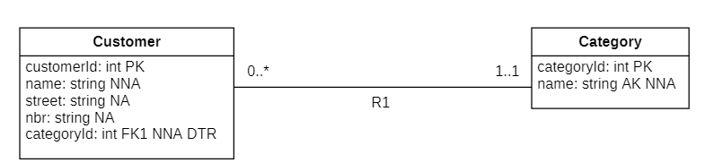

R1: a customer has one category; a category belongs to multiple customers

Priority by functionality
Indicate for all functionalities (use cases) which MoSCoW priority should be assigned.

Your text

Backlog with User Stories
Please paste a clear and readable screenshot of the Jira backlog here. Ensure that the Epic Stories (use cases) are also included. You may need to add multiple screenshots to guarantee readability.

